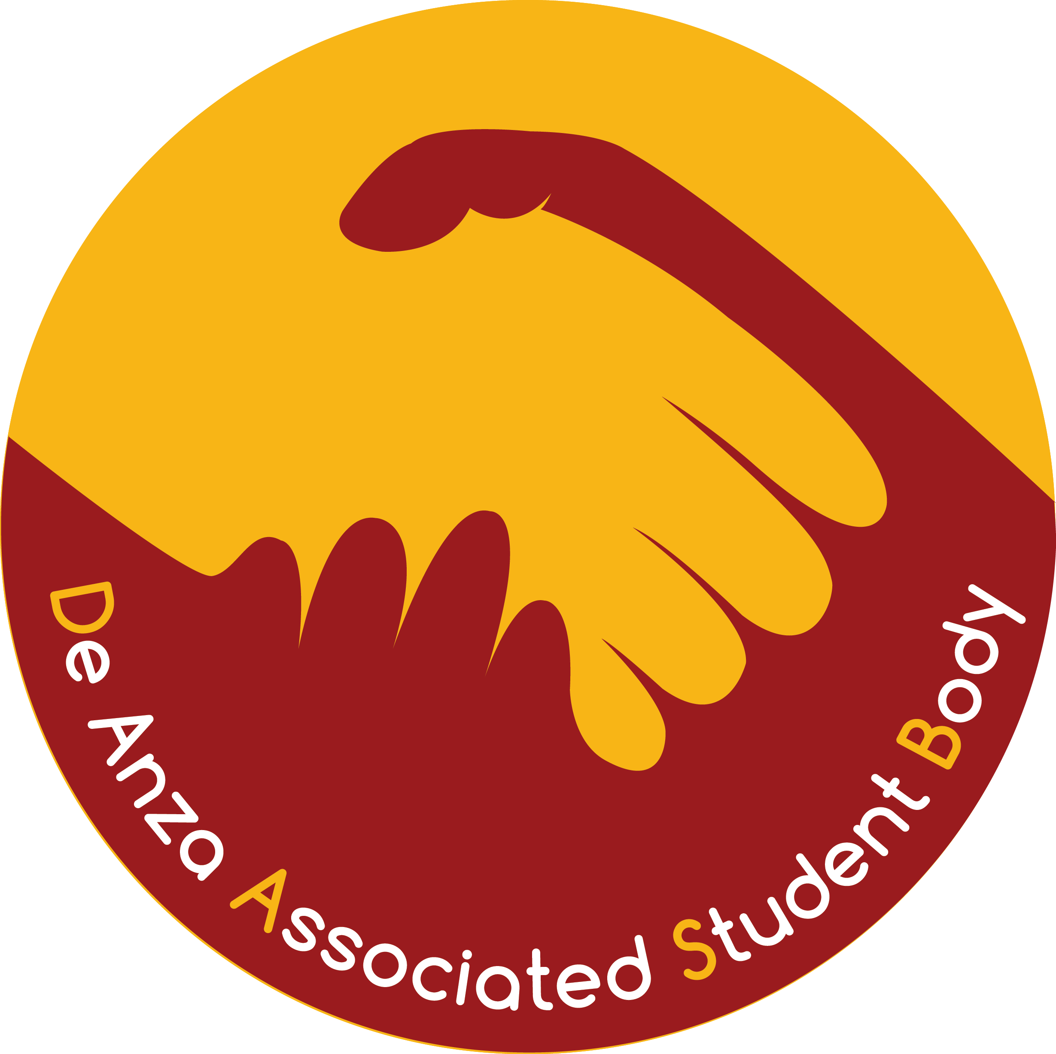 | De Anza Student Government  Finance Committee Budget Bulletin  For All Programs Excluding Athletics  Sharon Utomo, DASG Chair of Finance  September 27, 2021

★ Keep this Budget Bulletin/Cover Page for your reference. Do not submit with your application. 

The DASG is accepting requests for the 2022-2023 fiscal year budget. Use the attached application to request funding for the 2022-2023 fiscal year. If you have any questions, please contact Sharon Utomo, DASG Chair of Finance, at DASGFinance@fhda.edu , or Dennis Shannakian, Student Activities Coordinator, at ShannakianDennis@fhda.edu.

DASG 2022-2023 ANNUAL BUDGET FUNDING REQUESTS

Welcome to Fall Quarter 2021

In the tradition of “Students Working for Students”, the De Anza Student Government is beginning our annual budget process for the 2022-2023 academic year. Please read below for some changes that will be occurring for this funding cycle.

There is no guarantee of receiving DASG funding. DASG funds are intended to be supplemental and are not intended to fund your entire program, nor required items that are considered the responsibility of your program such as office supplies and office equipment. Please be reasonable in your request. The DASG Budget is comprised of two funds, Fund 41 General Fund, and the Fund 46 Student Representation and Advocacy Fund. Fund 46 can only be used for Student Representation, Advocacy, and related Leadership Training Activities. The DASG Finance Committee and DASG Senate will determine which Fund to use for your request.

- Any Request that is not fully completed will not be accepted. The more detailed information the better.

- The funding to be received is contingent on the quality of this application.

- Any Request that is not in by the due date runs the risk of being rejected.

Signatures are not Required for this Application
Signatures are not required for this application; however, the Administrator should still review and approve the application and should be copied on the email submitting the application. The Budgeter and Administrator cannot be the same person. Applications must be typed and submitted via email along with any attachments; applications must be submitted as Word documents or searchable text PDFs (not scans).

Signatures that are Required for Utilizing Funds
All future financial documents, forms, requests, requisitions require the signature of the budgeter(s) and the administrator responsible for the program of the account. The budgeter and administrator responsible for the program of the account shall sign designating this is an appropriate expenditure of DASG funds and in the best interest of the student body. Administrators are responsible for any expenditures exceeding budget allocations. The Budgeter and Administrator cannot be the same person.

Budget Information Meetings
For questions regarding funding possibilities, procedures, requirements, etc. please go to a DASG Finance Committee Meeting, Mondays at 4:00 PM on Zoom via https://fhda-edu.zoom.us/j/95221504982?pwd=MVQ1VWlncEVwL3Q4WHB1NFpjZDNvQT09 or link on DASG Budget webpage at www.deanza.edu/dasg/budget. All DASG Finance Committee Agendas from September 27, 2021 through October 25, 2021 will have time allocated for any questions.

2022-2023 DASG BUDGET CALENDAR

Monday, September 27, 2021 Budget Requests become available

Monday, November 1, 2021 Budget Requests due to the Office of College Life by 4:00 pm
Applications and attachments must be typed and submitted via email to Dennis Shannakian at ShannakianDennis@fhda.edu.
The Subject must be in the following format:
"DASG Budget Request - DASG Account/Program Name - DASG Account Number"
For Example:
"DASG Budget Request - DASG Budget Committee - 41-51140"
Everything submitted will be publicly available online.

By Friday, January 28, 2022 Proposed 2022-2023 DASG budget posted online at www.deanza.edu/dasg/budget
Those requesting funds should review this draft.

By Wednesday, February 2, 2022 Final proposed draft presented to DASG Senate as an Information item

By Wednesday, February 9, 2022 Final proposed draft presented to DASG Senate as an Action item for
First Vote

Monday, May 2, 2022 DASG Senate approved Budget presented to Board of Trustees for their approval.

Approved by DASG Chair of Finance (Produced by the Office of College Life - 9/27/2021)

DASG Budget Request 2022-2023
For All Programs Excluding Athletics
Budget Request due to the Office of College Life by 4:00 pm Monday, November 1, 2021
Applications and attachments must be typed and submitted via email to Dennis Shannakian at ShannakianDennis@fhda.edu.
Please also copy the Administrator on the email.
Applications must be submitted as Word documents or searchable text PDFs (not scans; signatures are not required)
The Subject must be in the following format: “DASG Budget Request - DASG Account/Program Name - DASG Account Number”
For Example: “DASG Budget Request - DASG Budget Committee - 41-51140”
Everything submitted will be publicly available online.
Delete the Object Codes and lines within Object Codes you do not need.

- Program (Account) Name:
- Is this a new DASG account? Yes  No  DASG Account Number:
- Amount requested for 2021-2022 $
- Total amount allocated for 2021-2022 $
- How long has this program existed?
- Number of students directly served in this program:
Please ACCURATELY and THOROUGHLY complete numbers 7 – 10 and use additional sheets if necessary.
- How have you been meeting or how do you plan to meet the budget stipulation of requiring that all students benefiting from DASG funds allocated to you have paid the $10 DA Student Body Fee and are DASG Members (DASG Budget Stipulation # 1)?
- What would be the impact if DASG did not completely fund this request?

- Total amount being requested for 2022-2023 (from page 3) $

Delete the Object Codes and lines within Object Codes you do not need.

Student Payroll (2310)
MUST ALSO COMPLETE THE BENEFITS (3200) SECTION
Must adhere to FHDA Student Pay Levels as stated at https://www.deanza.edu/financialaid/types/studentjobs.html
Job Title # of emp. x $ Per hr x # hrs/wk x # of wks Cost
1.
2.
3.
4.
5.
TOTAL: $

Hourly Benefits (3200)
MUST ALSO BE COMPLETED WHEN REQUESTING PAYROLL
Benefits rates can change each year. Please check rates before requesting the same amount as last year.
(1.52 % for Student Employees, 10.4 % for Casual Employees)
Job Title Total $ x Percentage Cost
1.
2.
3.
4.
5.
TOTAL: $

Supplies (4010)
(Non-capital as specified; NO general office supplies)
Item Intended Use Cost
1.
2.
3.
4.
5.
TOTAL: $

Food/Refreshments (4015)
(Must adhere to district Administrative Procedure 6331, http://www.boarddocs.com/ca/fhda/Board.nsf/goto?open&id=AKVUKX7C7F98)
Item Intended Use Cost
1.
2.
3.
4.
5.
TOTAL: $

Printing (4060)
(Flyers, posters, programs, forms, etc.)
Item Intended Use Cost
1.
2.
3.
4.
5.
TOTAL: $

Technical and Professional Services (5214)
(Limited Engagement/Independent Contractor Agreements,
Consultants/Guest Speakers/Entertainment (list programs).
For contracted speakers the fee shall not exceed $1,200 per speaker per event.
For performances the fee shall not exceed $1,800 per performance.)
Item Intended Use Cost
1.
2.
3.
4.
5.
TOTAL: $

Domestic Conference and Travel (5510)
(Must adhere to district travel policies,
http://business.fhda.edu/policies-and-procedures/ff-travel-policy.html,
and DASG Limitation and Requirements from the DASG Finance Code)

Item Intended Use Cost
1.
2.
3.
4.
5.
TOTAL: $

Capital (6420)
(Any durable item whose value exceeds $200 and has usable life of one (1) year or more;
NO general office equipment)
Item Intended Use Cost
1.
2.
3.
4.
5.
TOTAL: $

Total amount being requested for 2022-2023 (also complete line 9 at bottom of first page)

$

Delete the Object Codes and lines within Object Codes you do not need.

Request For Information (RFI)

 | Question / Inquiry | Program Response
 | Please provide a thorough description of your program. Please describe the new services or features of your program that were implemented after you last submitted a DASG RFI. Explain how your program is unique. Are there any programs on campus that are similar or is there any duplication of services?
 | How will your program expand students' perspectives and positively impact their lives and the community? (250 words max)
 | Go through the most recent DASG Budget Guiding Principles and explain how your program fits each of them or as many as possible. Please do not merely copy and paste the DASG Guiding Principles. The DASG Budget Goals/DASG Budget Guiding Principles are available at www.deanza.edu/dasg/budget
 | Explain how your program advertises and promotes itself to all students. Has your program made extra effort to market and reach underserved students? If so, describe how. If not, describe what challenges your program faces in trying to do so. Provide a clear plan for the current academic year as well as any marketing material you will or have used.
 | Explain how your program promotes equity within the program and on campus. For example: equity training for all staff and student leaders, hiring from underrepresented communities, etc.
 | How has your program adapted to providing its services online? Alternatively, please provide a clear plan for how your program would provide online services if needed in the future.
 | Please indicate which object codes are critical for DASG to fund this year. Please do NOT list down all of the object codes.

Data Sheets/Attachments
Please attach supporting documents of the following questions and list the document names accordingly.
Covering all the bullet points will be beneficial for our review process. IF attachment is not required or missing, please give your thorough answers below.

 | Question / Inquiry | Document Name / Additional Response
1. | ENROLMENT  - Number of total AND new active students over the past 3 years  - Number of enrolments retained (stayed for more than a quarter)  - Number of students enrolled in online services  - Does your program serve a certain demographic or the whole De Anza population?  - Racial demographics (if possible)
2. | STUDENT FEEDBACK  - Attach student feedback forms, surveys, etc.  - How has your program responded to suggestions made by students in the previous year?
3. | FUNDING  - List any funding from the college, sources of income, any grants, and any other source (include ALL Account Numbers, Account Names, Account Balances, and Account Purposes/Restrictions)  - Attach account reports of all sources of funding

Signatures are not Required for this Application
Signatures are not required for this application; however, the Administrator should still review and approve the application and should be copied on the email submitting the application. The Budgeter and Administrator cannot be the same person. Applications must be typed and submitted via email along with any attachments; applications must be submitted as Word documents or searchable text PDFs (not scans).

Signatures that are Required for Utilizing Funds
All future financial documents, forms, requests, requisitions require the signature of the budgeter(s) and the administrator responsible for the program of the account. The budgeter and administrator responsible for the program of the account shall sign designating this is an appropriate expenditure of DASG funds and in the best interest of the student body. Administrators are responsible for any expenditures exceeding budget allocations. The Budgeter and Administrator cannot be the same person.

Budgeter and Administrator Information

Budgeter’s Name:
Phone Number:
Email:
Relationship to Project:
Position on Campus:

Administrator’s Name:
Phone Number:
Email:
Relationship to Project:
Position on Campus:

Approved by DASG Chair of Finance (Produced by the Office of College Life - 9/27/2021)

